 NOVEMBER-DECEMBER 2021, VOL. 1, ISSUES 4-5
DR. ELSIE CLARK (APOSTLE)

WAR CRY NEWSLETTER WSLETTER

PROPHECY – BUILD A STOREHOUSE PROPHETESS SHERRI MYERS


Have you ever heard the voice of God? I mean really heard Him say something so profound it shocked your Spirit!
God spoke to me and said….Build a Storehouse! A Storehouse, Lord? What is that? Given it was 35 years ago, He said it! It has taken me that long to understand what He meant.
This was a Word of Prophecy for a future time. I’ve meditated on this Word since that time, trying to understand the seasons and times! But now is the – TIME! Today is the day — Build a Storehouse!
We have entered into a Prophetic Season–A Prophetic Time–A time of building! God told me, “Build a Storehouse just as Joseph built.”
This is for everyone all over the …WORLD!

People, build a Storehouse to prepare so that famine will not overtake you! Again, people build and prepare!

Prophetically, according to the Bible, “Long ago God spoke many times and in many ways to our ancestors through the prophets. And now in these final days, he has spoken to us through his Son. God promised everything to the Son as an inheritance, and through the Son he created the universe” Hebrews 1:1-2 New Living Translation.

Almighty God is still speaking through the voice of His prophets. The prophetic Word that God gave me is confirmed by many other prophets or prophetesses in this hour.
In my political travels and/or conferences, I have seen many things that are unfolding, prophetically.
Therefore, I am taking the opportunity to reveal the prophetic Word that God gave me, because of its great urgency. I literally saw famine and it was very difficult for people to acquire food.
It is my time to reach out to people on a global front to give them a prophetic warning of what shall befall the earth in these last days.
The Word of God says, “Believe in the Lord your God and you shall be established; believe and remain steadfast to His prophets and you shall prosper” 2 Chronicles 20:20 AMPC.
Prophetically speaking, when you obey God’s prophets, you shall prosper or succeed!
God bless each of you for taking out time to read this important prophetic Word that came to me from Christ by the Holy Spirit. Christ said, “He who has ears to hear, let him hear and heed My words” Matthew 11:15 AMP.

God’s Word – the Sword of the Spirit

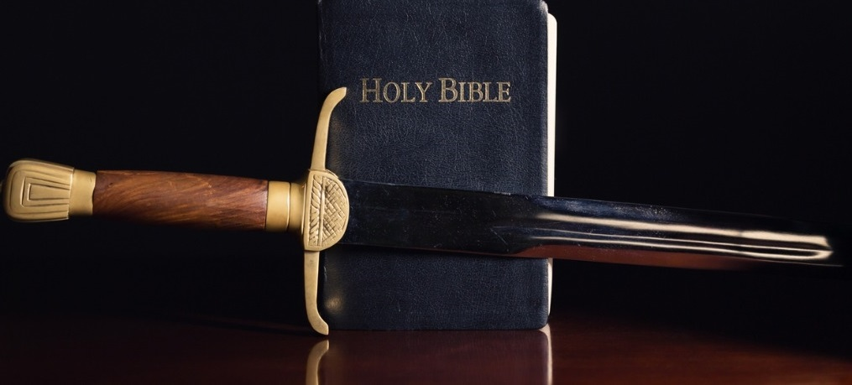
Rise up soldiers of Christ and take your positions with God’s Word, the sword of the Spirit!
WAR a good warfare
1 Timothy 1:18
God said, “And take the helmet of salvation, and the sword of the Spirit, which is the Word of God” Ephesians 6:17 AMP.
In addition, He revealed the power of His Word like unto a two-edged sword. SEIZE your moment with the power of God’s Word!
- “For the word of God is living and active and full of power [making it operative, energizing, and effective]. It is sharper than any two-edged sword, penetrating as far as the division of the soul and spirit [the completeness of a person], and of both joints and marrow [the deepest parts of our nature], exposing and judging the very thoughts and intentions of the heart” Hebrews 4:12 AMP.
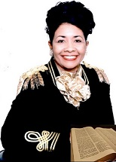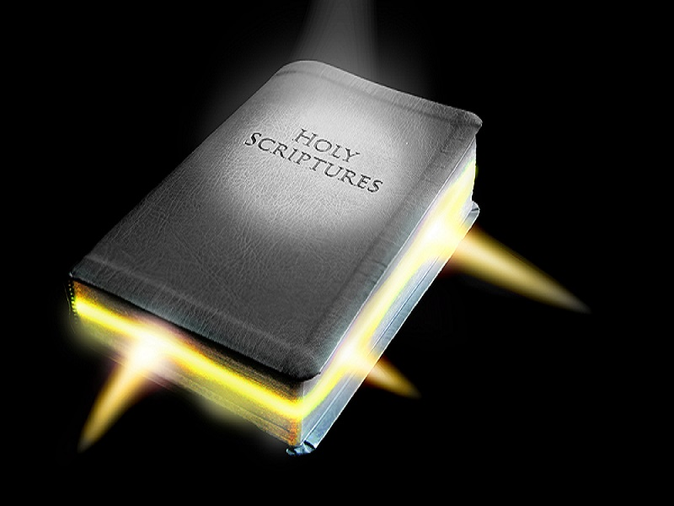
We are in the last days and we must take the Word of God as the sword of the Spirit to war against the onslaught attacks of Satan in these last days.
There is an unseen war that is breaking forth in the earth like never before. Many are unprepared to handle the monstrosities that are about to confront us.
Strange phenomena shall come forth and many people shall not believe what they are witnessing. They will question what they see, but will not be able to dispute it.

The Light of God’s Word comes out like a sword that demolishes the works of the adversary.
His Word is the “SWORD OF LIGHT” that consumes spiritual darkness that has covered the eyes of unbelievers and some Christians.
God said, “For once you were full of darkness, but now you have light from the Lord. So live as people of light! Ephesians 5:8-9 New Living Version.
We are called “children of light” in KJV. Therefore, we must walk in the Light of Christ, which shall protect us when great evils shall break loose!
When we walk in the Light of Christ, the dark forces of this world must flee!


PROPHECY OF GOD’S LIGHT
Given to Dr. Elsie Clark (Prophetess) on Thursday, December 02, 2021 at 5:20 AM (CST)
I heard the Lord say, “My Light shall be a sword against the dark evils that shall plague the land.”
Walk in My Light as children of Light, saith the Lord. I will shield You from the plagues of evil that shall unfold in the earth like never before.
Cast away your dark evils so that My Light shall cover You in the time of trouble.
Hearken unto My Words, saith the Lord and enter into My rest where You will find peace.
Look not at your situations or circumstances, but look at My Word, saith the Lord. My Word is the sword of the Spirit that shall war for You beyond your understanding.
You will not be aware of how I shall shield You from unseen forces that shall manifest themselves in the natural realm of this earth.
Are you prepared saith, the Lord? I shall prepare You in ways you know not of. I shall bring forth My Light that shall scatter your enemies far from You.
My Light shall shield You like unto the time when I was a cloud in the day to guide my people and a fire at night to lead them through the dangers of the wilderness (Exodus 13:21-22; 14:24; 40:38)
Do You not know My plan, saith the Lord? My plan is to bring forth a prepared people in the earth that shall stand on My Word and use it against the evils that shall taunt many.
Walk in the Light of My presence that radiates My glory as a defense shield for You! I am a sun and shield for You and will hold no good thing from those that walk uprightly before Me, saith the Lord— Psalm 84:11.
Lend Your ear to My Word, saith the Lord and You shall be protected in the times of great trouble that shall quickly befall this earth.
Do not be in the dark place when evil strikes, but be in My Light, saith the Lord. For the dark places are the domain of sin that lurks in the dark spheres of the earth.
Great portals of darkness shall open up in the domain of the earth and only My people shall be shielded from these great atrocities.
Hearken unto My Word, saith the Lord while it is still time. Do not rebel against Me or My Word, for You shall enter into a realm of darkness where evil shall strike in Your blindness. Obey the Word of My true prophets, saith the Lord.
My Light shines before all men that follow after Me and My Word. Do not walk in the shadow of darkness where evil doth lurk. Dark creatures shall plague the atmosphere, but My children shall walk in the atmosphere of My Word and My Spirit, saith the Lord.
Abide in Me and I shall abide in You, saith the Lord of Hosts. End of Prophecy

Warriors of the Word
THE OUTPOURING OF MY WORD PROPHECY:
Given to Dr. Elsie Clark on Thurs., Dec. 2, 2021 7:44 AM

I hear the Lord saying, “I shall pour My Word out into the earth through My prophets.” They shall speak what I speak unto them and shall not compromise My prophetic truths, saith the Lord. I shall speak unto them very hard sayings into the ears of many. I shall not hold back, for the time is short and soon for My return. I shall not spare those that fail to hearken unto Me, saith the Lord. Get into My Word and seek My face like never before. Adhere to My sayings and You shall be protected from My wrath that shall speedily come forth in this earth, saith the Lord.

PROCLAIMING GOD’S TRUTHS
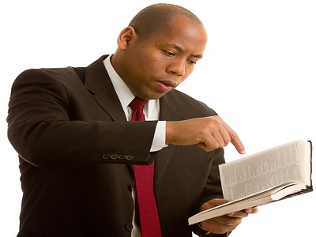
Hear and obey the Word of the Lord, because He has issued prophetic warnings that shall come to past.
Enlighten yourselves in His prophetic truths so that you will not lack understanding of His life-saving truths. Through God’s Word, you shall be spared from the great troubles that are forthcoming!
Study and do your best to present yourself to God approved, a workman [tested by trial] who has no reason to be ashamed, accurately handling and skillfully teaching the word of truth—2 Timothy 2:15 AMP.

ISRAEL – A PROPHETIC CLOCK


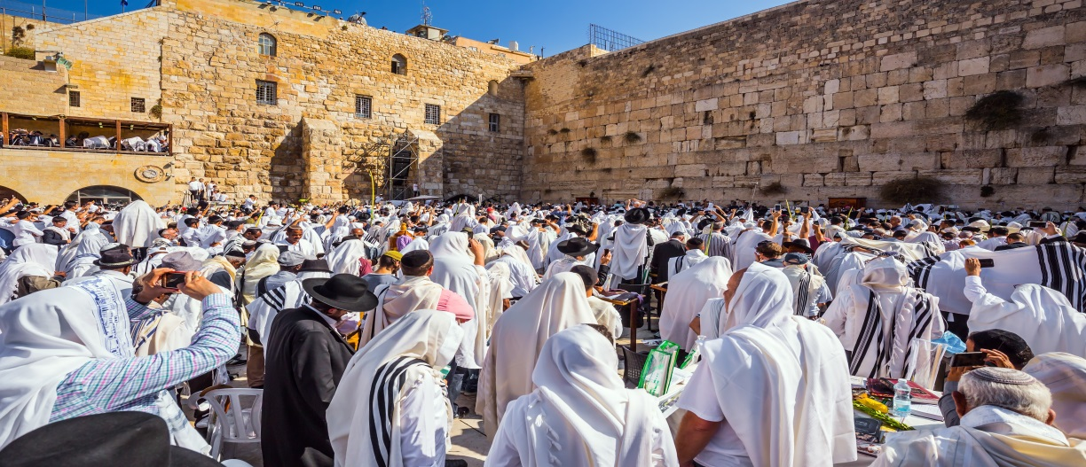
Israel is a prophetic time clock, because the news events of its nation are reflections of prophetic fulfillments.
God gave Dr. Elsie Clark the following prophecy concerning God’s love for ISRAEL:

Hear Oh Israel; hear the voice of the Lord. His voice is like the rolling thunder. Hear His Voice.

All that hear His Voice shall rejoice in Him. Weep Oh Israel, weep for His coming.

His coming draws nigh. Get before your altars and weep before Him. For He is your God, your Everlasting Father.

In Him, you will find peace and rest. You will have solitude in Him.

You must pray and seek My Face Oh Israel. It is time to pray and seek My Face for evermore.
My time is soon approaching. Many are not saved. It is time to seek Me while there is still time.

Receive My Covenant and Obey My voice. Hearken unto My Words, Oh Israel, My son. Oh how I love you, My departed son, Oh how I love you.
Come nigh unto Me My children. Come nigh unto Me. It is time.

You are My children that I have taken upon Eagle Wings; Yet, you did fly.

It is now time that you soar like an eagle. I have nourished you from the breast of My Word. You have drank of the milk of My Word.

You have eaten of the meat of My Word. I have sent down manna from above. I have cared for you.

I have placed you in your nest until it was time for you to soar. You must now choose whom you are going to serve.

Listen My people, hearken unto My Word, it is now time that you seek Me like you never have before.

Get before the Wailing Wall and cry and wail before Me. Wail for My coming and My r-e-t-u-r-n, saith the Lord. I shall come for those that seek My face.

Those that seek My face, I will turn My wrath from them. I say again to you Oh Israel, you must seek My face while it is yet time.

Many things shall befall this earth and many things that I have before prophesied shall come to pass before your very eyes.

You will see an unveiling of events that I have prophesied in My Word … then shall you know that I am your God.

I am the God of all truth that seeks after you. You must seek My truth saith God, yes My truth.

The truth shall make you free. In My Word, you will find ‘strength.” You will move from a realm of spiritual desolation to a realm of spiritual wealth.

I have sought you out as a nation of people and taken you under my wings. You are My called and chosen people saith the Lord.

Many are called, but few are chosen. I know who are mine, saith the Lord. You must not be persuaded by the imposter that shall come with lying and deceiving wonders.

He is a master-mind of pure deception. You must not follow Him, for you shall be known by your fruits.

I know who are Mine, saith the Lord. I am bringing forth a “Warning Call” saith the Lord. You must now hearken.

There is coming great disasters, such disasters like man has never seen nor experienced.

You must prepare yourselves in Me, saith the Lord. In Me, you shall find “refuge.”

In Me, you shall not fear those things that shall come upon the land. These things shall come abruptly and quickly.

Many will not have time to do what seems to be common.

Only those that have the oil in their lamps shall be able to go with Me.

Many will be left, because they had no oil in their lamps. Many sought after their own pleasures and not the pleasure of serving their One and Only Creator.

I am God and there is no other. I am He. I am the God of Abraham, Isaac and Jacob, saith the Lord. I am He.

I Am that I Am. I was before all creation and I am at the end of all creation. I am the Eternal God … the Eternal Father … I am He.

I am coming for a remnant of people that will serve Me out of every race of people. I am no respecter of persons, saith the Lord.

Come nigh unto Me and sup with Me, saith God.

Come in to My Bridal Kitchen and dine with Me saith the Lord.

I have prepared My Royal Supper where you can fellowship with Me and eat at My table saith the Lord.

Come and take of the Bread and Wine of My Spirit, saith the Lord.

You are My chosen … My bride … whom I have chosen out of every race. You are … one … with all those that follow Me, saith the Lord.

In My house are many mansions, even as I have told you. Come now My dear ones, come, I say come and sup with Me. Come and take of My Word.

Eat of My Word saith God, eat of My Word. My Word is spiritual meat indeed. You shall walk in My Glory, saith the Lord.

You shall walk in the Glory of My Word and My fulfilled promises, saith God.

My Glory shall fill the earth and the heavens. I shall pour My Glory out and all shall see and know that I am He; I am the Only True and Divine Notable One.

I am King of kings and Lord of lords. There is none other, for I am He. Look toward Me Oh Israel, I am your Helper indeed. I am He.

I will help you, I will be your Saviour, I will be your God, the only ‘True’ and Living God.

Receive Me now and Come unto Me where you will have “Eternal Rest” in My Kingdom, saith God.

I seal this with My Eternal Love, saith the Lord God of Hosts.

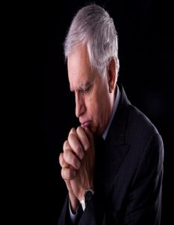

JOIN ONLINE - GLOBAL PRAYER WARRIORS OF ARMY OF THE LORD

A Congress of Prayer Leaders

Experience the power of unified prayer



PREPARE FOR SPIRITUAL BATTLE 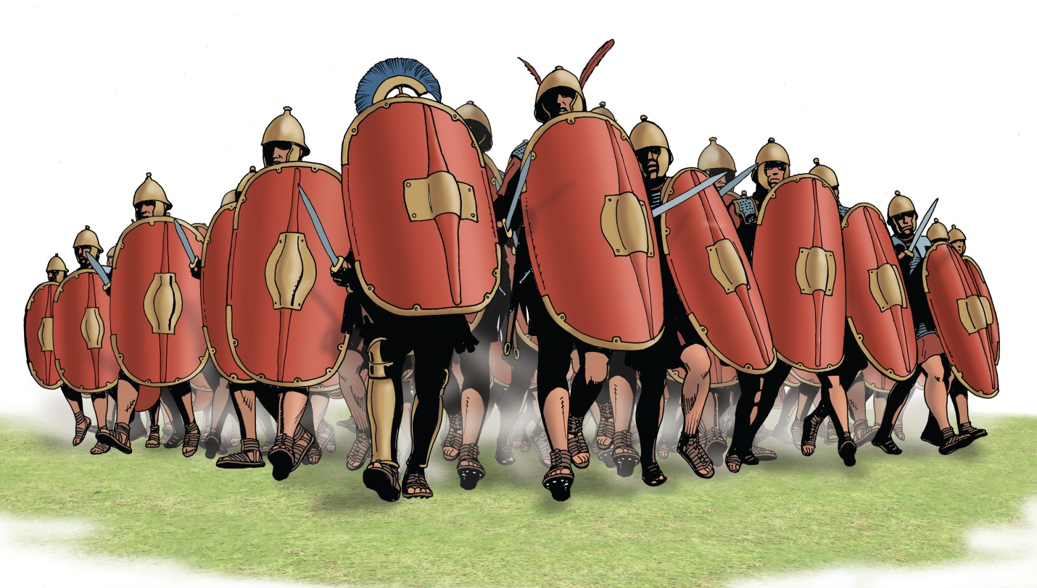Order Your Spiritual Warfare Books 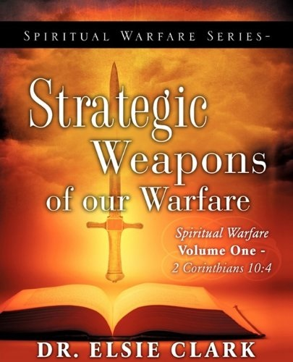 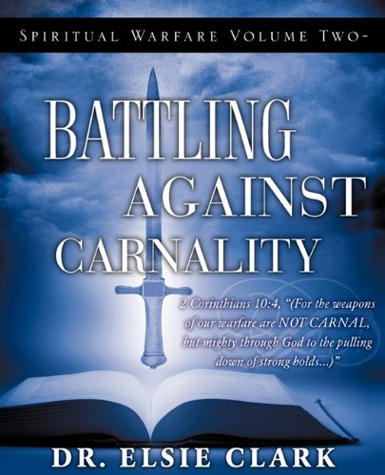

Sold on Amazon, Barns and Noble, Xulon Press
Dr. Elsie Clark
Army of the Lord Christian Ministries – Global Prayer Warriors
4209 Lakeland Drive #340, Flowood, MS. 39232
Email: drelsieclark77@gmail.com Website: www.drelsieclark.org

